**Now IT sector condition in a ‘Boom or Recession’?**

*By* [*Falguni Bhoi*](http://www.linkedin.com/in/falguni-bhoi-40008a223) *– October 7*

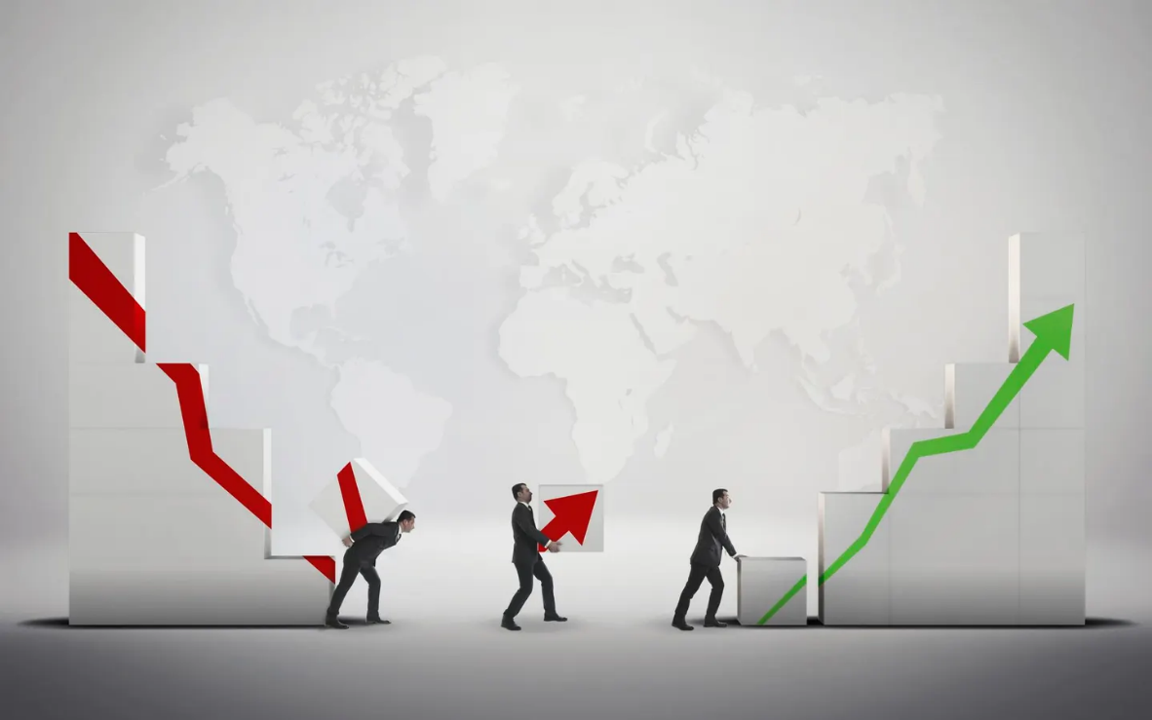

*Image source – Forbes*

Since 2022, the IT sector has undergone a massive recession. On the top, in the first quarter of this year, the industry witnessed few layoffs or recessions, both globally and domestically.

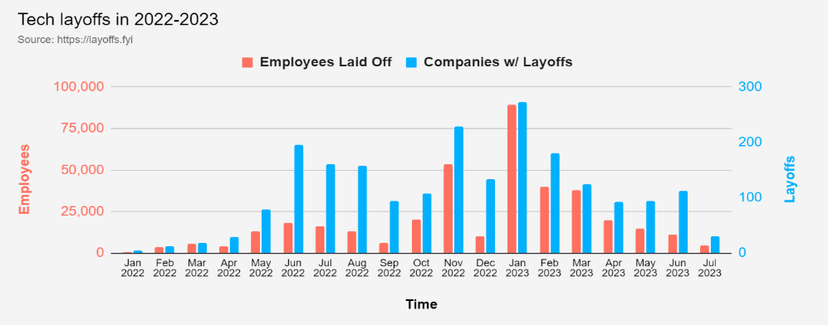

*Image source- Layoff. FYI*

If we look at the recent data, the recession is still present, but to some extent. The industries are not getting so much affected, moreover, some companies are on the verge of recession, still started rehiring their employees.

**Factors Causing Recession –**

1. **Twin-Black Swan- Pandemic & Russia-Ukraine conflict:**

The ongoing conflict between Russia and Ukraine is a [black swan event](https://nasscom.in/knowledge-center/publications/technology-sector-india-2023-strategic-review#block-factsandfigures2023). This event indicates when any activity occurs suddenly after three to five years. Now, this has severely affected the businesses and, trickled down the IT firms. Businesses are getting cautious about investments in the IT sector, as in the previous, nearly 80% of the IT companies in Ukraine were supposed to shut down due to the war. Now, another black swan event was- the Covid-19 pandemic. This caused industries to realise that the presence of their service must be diverse not sticking up to a particular location.

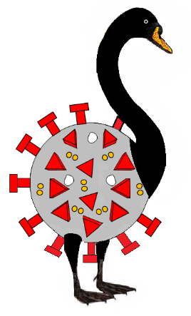

1. **Skilled Personnel:**

The shortage of skills is affecting almost every industry and organization across the globe. According to the data of [IDC](https://www.idc.com/getdoc.jsp?containerId=prAP50511823) (International Data Corporation), the shortage of skilled labour causes workload, reducing customer satisfaction and loss of critical knowledge. The top companies are also seeing a huge number of vacancies. Due to this upskilling and giving training to new candidates is getting difficult for companies.

1. **Global Inflation:**

The sudden rise of the prices in the area consisting of servers, storage, and professional services, is creating problems for the supply chains. Moreover, the inflation and the demand for [tech services](https://phoenixcellular.com/news/how-inflation-is-affecting-the-tech-industry/) will also be high. Hence, in the following data, it shows. How the PPI over the year 2022, has mixed growth. But somehow, currently, it is in a better state.

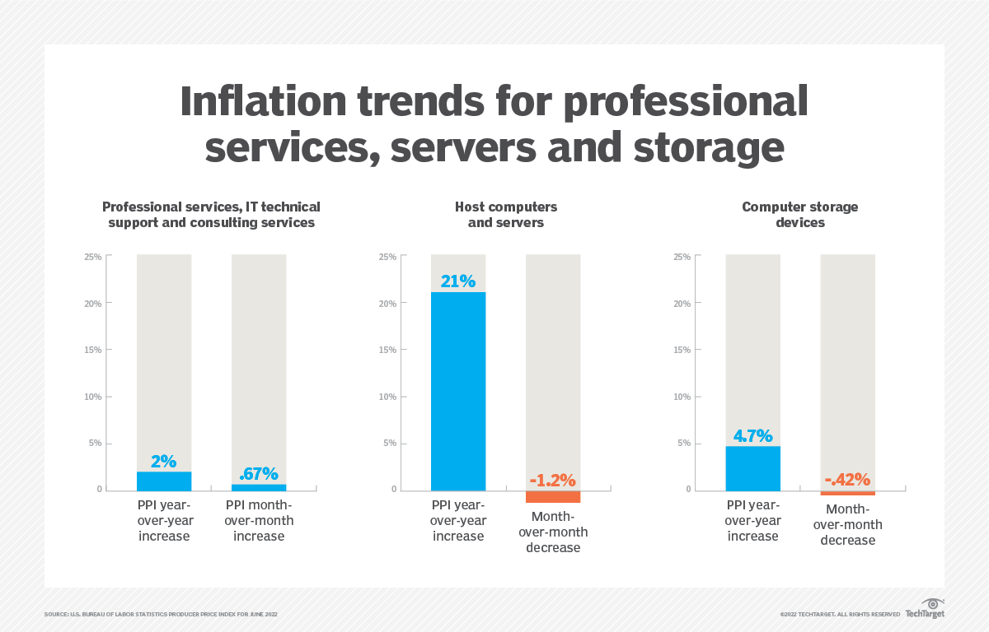

1. **The Tech War:**

Presently, [the tech war](https://indianexpress.com/article/technology/tech-news-technology/us-china-tech-war-risc-v-chip-technology-emerges-as-new-battleground-8973159/) going on between the U.S. and China is creating a disturbance globally. The war is all about the U.S. cut-off with semiconductors from China. While China is focussing on being self-sufficient and putting a halt on American technology. Both countries want to become supreme in the technology world but no one is ready to take back off.

**Strategies used to navigate during the recession-**

**Expanding the offerings:**

The IT companies that offer a range of services and products are willing to face the recession because they hold the power to turn their [services](https://connect.comptia.org/content/research/it-industry-trends-analysis) diversely with the growing technologies and market.

**Customer Service:**

Now, focusing on customer service is another important thing. In times of difficulty, a strong consumer base or maintaining a good relationship with the consumer benefits the company during the time of recession. However, it attracts newer consumers to the company.

**Investment in Innovation:**

Investing in innovation can lead to the creation of [new technology](https://www.thoughtworks.com/en-in/what-we-do/digital-solutions/innovation-during-recession#:~:text=Embrace%20technology%20as%20the%20source%20%E2%80%93%20or%20the%20vehicle%20%E2%80%93%20of%20innovation). In the area of Cybersecurity, if the investment is done here. Then, this may become the saviour for the companies during the period of recession.

**Upskilling of working personnel:**

IT companies are now offering [training programs](https://www.cxotoday.com/cloud/how-indian-it-sector-is-upskilling-and-reskilling-employees-towards-digital-readiness/) for their employees to make them skilled and to keep an eye on the new emerging technologies and trends in the market.

**Conclusion:**

In the end, the IT sector has progressed a lot in recent years. Moreover, factors like the global economic crisis, demand for technologies etc, have become the major reasons behind recession in the industry. However, if look at the current scenario, the IT sector is in a “flux” state. So, we can’t predict anything exactly. Hence, we hope that there will be no recession shortly.